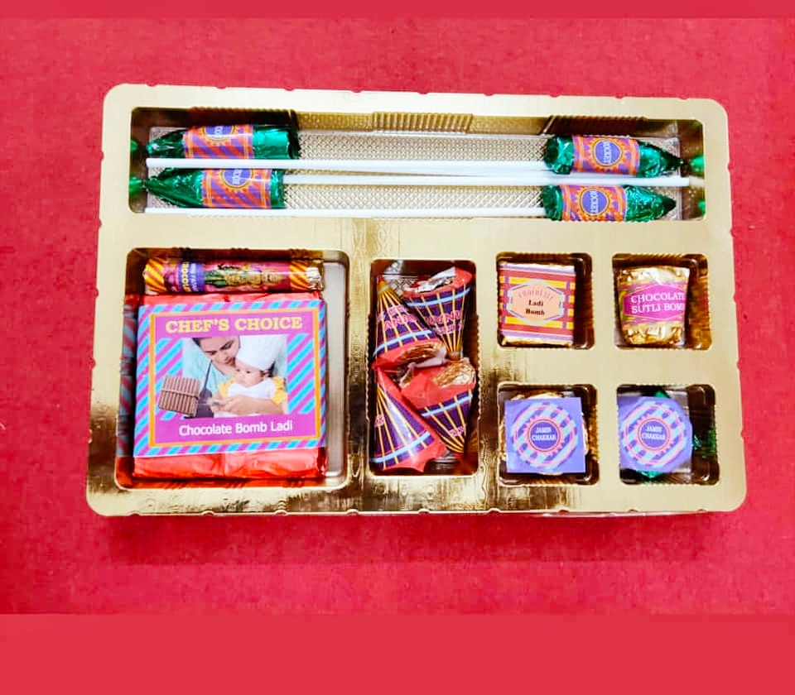

**THIS IS PLAIN CHOCHOLATE AND RICE CRISPY**

**FIRE CRACKERS THEME CHOCOLATES PER 250 GRAMS Rs. 575/-**

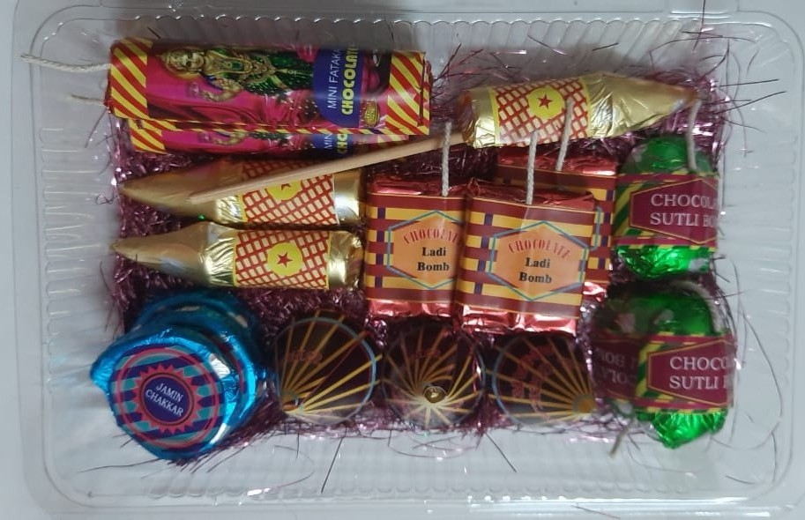

**THIS IS ALSO PLAIN RICE CRISPY AND COFEE**

**FIRE CRACKERS THEME CHOCOLATES PER 250 GRAMS Rs. 511 /-**

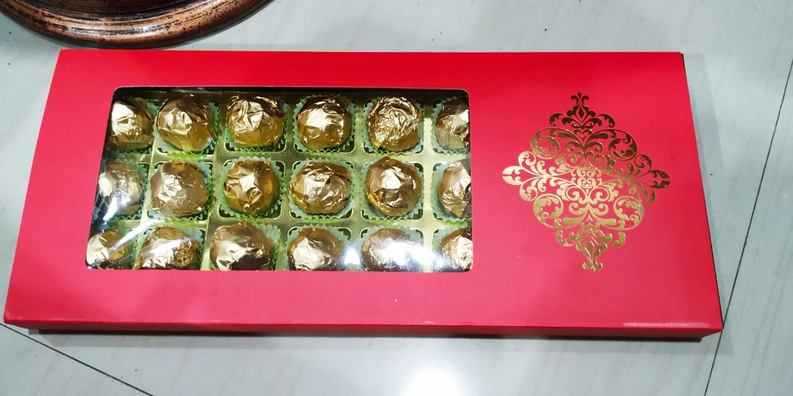

**RASMALAI..KAJU KULFI..ROASTED ALMOND**

**ASSORATED CHOCOLATES PER 250 GRAMS Rs. 675/-**

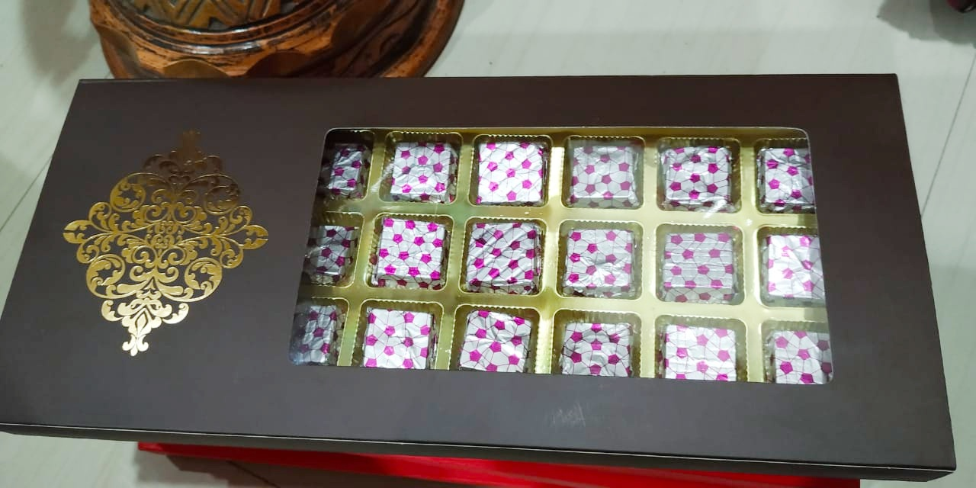

**RASMALAI..KAJU KULFI..ROASTED ALMOND**

**ASSORATED CHOCOLATES PER 250 GRAMS Rs. 675/-**